Press Release

Cincoze Unveils GM-1000 Rugged Compact GPU Computer
Delivering an Outstanding Computing Performance for Space-limited Applications

May 11th, 2020 – Cincoze, a professional manufacturer of embedded systems, unveils the GM-1000 rugged GPU computer, which is powered by the 9th/8th generation Intel® CPU and supports one MXM GPU module expansion. This GPU computer provides high-performance computing capability with a small footprint design, which is suitable for applications like edge computing, machine vision, image processing, and artificial intelligence.
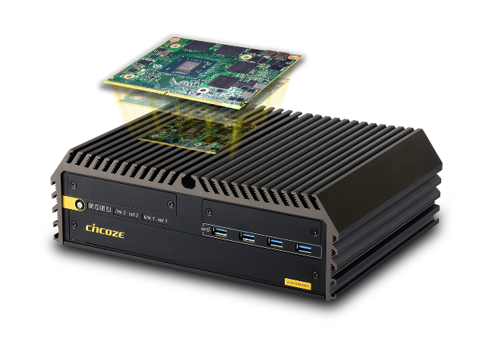
GM-1000 can be configured with a range of 9th/8th generation Intel® CPUs, including Xeon® and Core™ i up to 8 cores. It supports dual channel DDR4 2666MHz SO-DIMM up to 64GB. It has abundant I/Os, including 4 x COM, 2 x GbE LAN, 8 x USB, 1 x HDMI, and 1 x DVI-I. GM-1000 comes with an M.2 M key slot to support NVMe SSD, and M.2 E key slot to support CNVi for WiFi or Bluetooth connection which are commonly required in high speed data storage and communication. All these functions are integrated in a small footprint just 260 mm x 200 mm x 85 mm, making it easily installed in space-limited environments.

GM-1000 is designed with a power budget up to 360W which provides sufficient power for CPU and GPU to operate simultaneously. Additional GPU computing acceleration is realized through MXM 3.1 Type A/B expansion slot, which allows it to expand with an embedded GPU module from various manufacturers up to 160W.

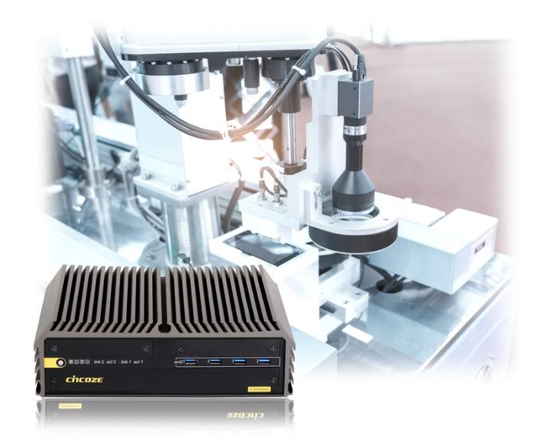
To handle tremendous heat, which is generated from high computing power, the system adopts a unique thermal design including independent cooling systems for CPU and GPU, copper heat pipes and a special aluminum extrusion case. An optional external fan kit with 4 x individual fans is also available to create an active airflow.

Thanks to Cincoze’s innovative CMI (Combined Multiple IO) and CFM (Control Function Module) technologies, it allows GM-1000 to expand additional functionalities according to customer’s needs. GM-1000 has multiple CMI interfaces to accommodate ready-to-use I/O modules, such as 2 x 10GbE LAN, 4 x GbE LAN, 4 x M12 GbE LAN, 16 DIOs, 2 x COM. Whereas CFM interfaces allows installing CFM modules for adding POE and power ignition sensing functions

To ensure reliability in extreme environments, GM-1000 is designed with high tolerance of vibration (5G) and shock (50G), wide range of voltage input (9~48 VDC), Over Voltage Protection, Over Current Protection and ESD Protection. The system is also certified with E-Mark for in-vehicle applications, EN50155 rolling stock standard, and EN62368-1 safety requirement.

"To fulfill booming demands of the embedded GPU market, Cincoze has introduced our first rugged GPU computer GM-1000 in our product portfolios. GM-1000 delivers efficiency and productivity for advanced industrial applications.” said Brandon Chien, CEO of Cincoze.

For additional information on Cincoze’s GM-1000, please visit: https://www.cincoze.com/goods_info.php?id=320.

About Cincoze
Cincoze is a professional manufacturer of embedded systems. We design, manufacture, and market rugged fanless computers, industrial panel PCs and monitors for demanding industrial applications and harsh environments. With the most innovative technology and a focus on customer needs in the field, Cincoze provides product solutions seamlessly integrated in customer’s applications, from factory automation, machine automation, machine vision, in-vehicle computing, intelligent transportation, to security & surveillance.

Press Contact
Julia Hsiao
Phone: +886-2-2918-8055 ext.1258
E-mail: julia.hsiao@cincoze.com
www.cincoze.com

