May 19, 2025

**MSI Showcases AI-Driven, High-Performance Innovations at COMPUTEX 2025**

*From AI servers and AI supercomputers to smart energy and industrial automation, MSI drives real-world AI deployment across industries.*

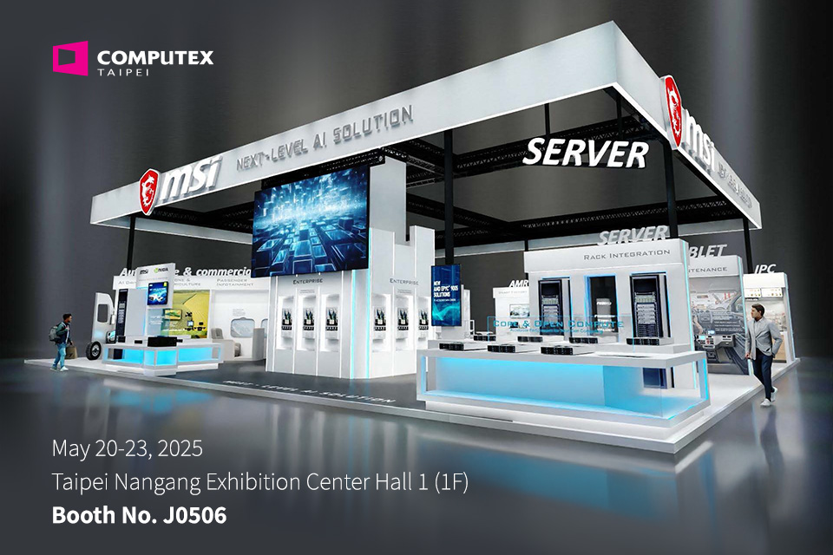

MSI, a global leader in gaming and high-performance computing, announces the launch of its comprehensive AIoT solution lineup at COMPUTEX 2025, featuring AI servers, AI supercomputers, smart energy, industrial PCs, and intelligent transportation systems. The showcase extends beyond core AI computing to system integration, hardware innovation, and cross-domain applications—demonstrating MSI’s leadership as a provider of AI-driven and high-performance technologies for next-generation industries.

“AI is no longer just a trend—it is a critical engine driving industrial intelligence,” said Sam Chern, MSI Vice President of Marketing.“With deep hardware R&D capabilities and a strong focus on high-performance and AI-integrated systems, MSI is expanding its reach from data centers to the edge, from energy management to smart manufacturing. Through this showcase, we hope to present our vision for a smarter, cross-domain technology future.”

**Product Highlights｜**

**AI Servers × Cloud Infrastructure(照片待補)**

Full-Rack Integration

MSI presents turnkey rack-level infrastructure, including 19” EIA, 21” OCP ORv3, and NVIDIA MGX AI racks.

* The EIA rack targets dense compute environments such as private clouds and virtualization.
* The OCP ORv3 rack features an open 21” chassis with 48V power delivery and OpenBMC support for hyperscale data centers.
* The AI rack, aligned with NVIDIA’s reference architecture, supports MGX modular systems and NVIDIA Spectrum-X networking, enabling multi-node GPU scaling for AI training and inference. All racks are deployment-ready and thermally optimized.

Core Compute Servers

MSI expands its DC-MHS modular server lineup with AMD-based CD270-S4051-X4/X2, CD281-S4051-X2 and Intel-based CD270-S3061-X4/X2, CD270-S3071-X2. All systems feature 2U4N or 2U2N form factors, PCIe Gen5, DDR5, and support up to 12 NVMe drives or 16 DIMM slots per node—designed for modular, high-density, and I/O-optimized cloud workloads.

AI Platforms & NVIDIA® DGX Station

MSI introduces MGX GPU servers for AI workloads:

* CG480-S5063 (Intel) and CG480-S6053 (AMD) support 8 FHFL dual-width PCIe 5.0 GPUs, 32 DDR5 DIMMs, and up to 20 E1.S NVMe bays (Intel).
* The CG290-S3063 (2U) supports 4 FHFL dual-width GPU and 16 DDR5 DIMMs slots in a compact design, ideal for edge inferencing and lightweight AI training.
* The CT60-S8060 DGX Station, based on NVIDIA GB300 Grace Blackwell Ultra Desktop Superchip, delivers up to 20 PFLOPS of AI performance, 784GB of unified memory, and up to 800Gb/s networking—tailored for on-prem training, distributed inference, and collaborative R&D.

Enterprise Platforms

MSI delivers complete solutions across DC-MHS and standard architectures:

* DC-MHS platforms include CX270, CX171, CX271 servers and HPMs such as D3066, D4056.
* General-purpose systems include the S2206 (dual-socket AMD EPYC) and CS280-S3065 (Intel Xeon 6, 2U 24-bay storage).
* Motherboards span ATX and uATX form factors, supporting Intel Xeon 6 and AMD EPYC 9005/8004/4005 processors—designed for scalable cloud, virtualization, and storage deployments.

**Industrial PCs × Rugged Tablets**

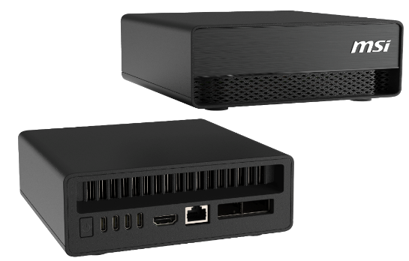MSI debuts the EdgeXpert MS-C931, a desktop AI supercomputer built on the NVIDIA DGXTM Spark platform.

Powered by the NVIDIA GB10 Grace Blackwell Superchip, it delivers 1000 AI TOPS FP4, 128GB unified memory, and ConnectX-7 networking—ideal for developers in education, finance, and healthcare sectors.

Also introduced are three software tools:

* MSI SysLink: Remote device management
* MSI ScreenLink: EDID Lock for digital signage
* MSI AI SmartLink: Seamless integration with large language models

These tools complement MSI’s full line of Box PCs and embedded boards, designed for next-generation AI and industrial automation.

MSI debuts two new rugged tablet models—the NB41 and NE21—designed to meet the demanding requirements of field workers and industrial environments.

* NB41 features an 8-inch display and is equipped with an Intel Alder Lake-N processor. It is MIL-STD 810G certified, drop-tested to 1.5 meters, and rated IP65 for dust and water resistance. It supports Wi-Fi 6E, Bluetooth 5.3, and offers a 7-hour battery life with hot-swappable capability, ensuring continuous operation in mission-critical scenarios.

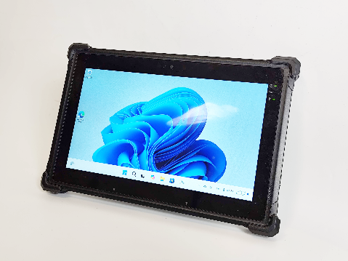

* NE21 is an 11.6-inch model powered by a 13th Gen Intel Raptor Lake Core i processor. It features an 800-nit sunlight-readable LCD, IP65 water/dust protection, MIL-STD 810G certification, and 4G LTE support. With a 7.5-hour battery, it is ideal for field deployments requiring extended mobile connectivity.

Both tablets support a range of accessories, including shoulder straps, hand grips, styluses, and tablet stands—providing ergonomic flexibility and operational durability for warehouse, logistics, manufacturing, and utility applications.

**EV Charging × Smart Energy**

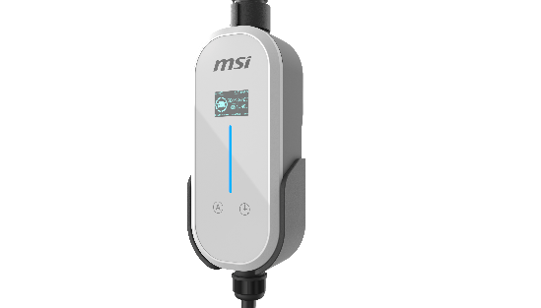EZgo Portable EV Charger

MSI EZgo supports up to 11kW output and features IP66 waterproof/dustproof housing. Interchangeable plugs support international standards (US/EU/TW/JP/KR/AU/Industrial), and it is UL2263 and UL817 certified. Built-in 1.8” display and Bluetooth app enhance user control. It withstands up to 2-ton enclosure weight and 20-ton cable crush force, and includes warranty and insurance support.

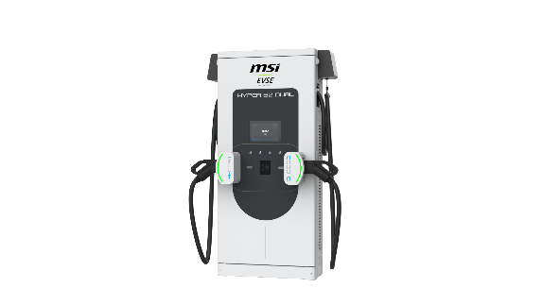MSI Hyper 80 Dual

This ultra-slim 80kW dual-gun DC fast charger measures just 30cm thick. With ISO 15118 and DIN 70121 support, Plug & Charge, and dynamic load balancing, it is optimized for urban and commercial charging environments. Its overhead cable system reduces wear and extends service life.

MSI EV/Eco Series & eConnect EMS

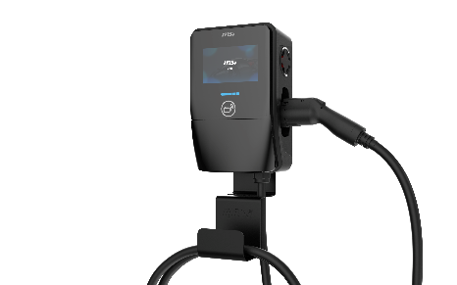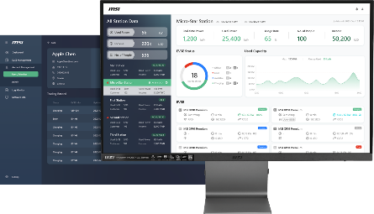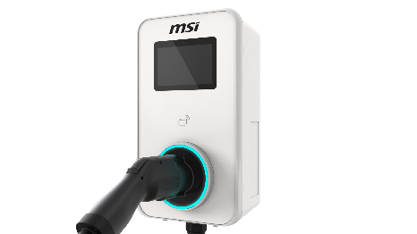These residential/commercial units feature solar-ready integration, 13kW (single-phase) or 22kW (three-phase) output, and AI license plate recognition. The eConnect EMS offers remote control, dynamic load management, and multi-user billing via a user-friendly interface—recipient of the iF Design Award.

**Autonomous Mobile Robots (AMRs) × Smart Manufacturing**

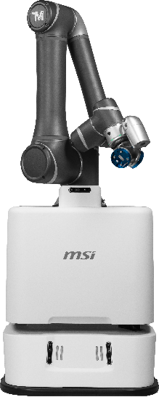MSI will highlight its latest AI-powered Autonomous Mobile Robots (AMRs) built for smart manufacturing and warehouse automation. Built on NVIDIA Jetson Orin Nano system-on-modules, NVIDIA Isaac robotics platform, and NVIDIA Omniverse, MSI AMRs enable real-time navigation, intelligent fleet coordination, and digital twin simulation.

MSI will showcase two flagship AMR models, each tailored for different smart factory needs:

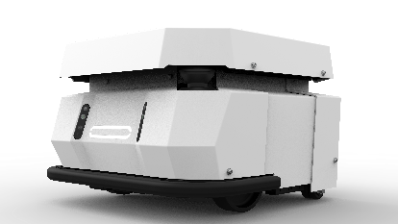● AMR-AI-Cobot Pro: Robotic arm with AI vision for precise material handling and assembly

● AMR-AI-Base Robot: Intelligent delivery and sorting solution for automated warehouse operations

Both models integrate advanced features such as LiDAR-based SLAM, AI-driven motion planning, and energy-efficient battery management—helping factories improve efficiency, reduce costs, and scale operations.

MSI unveils its latest AMRs powered by NVIDIA Jetson Orin Nano, Isaac robotics platform, and NVIDIA Omniverse.

**Smart Transportation – Fleet Management Solutions**

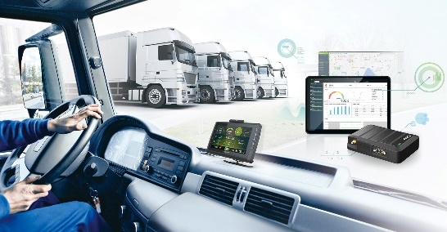MSI is expanding into smart transportation with a diverse range of fleet management products. The product line includes fleet management tablets, telematic boxes with license plate and object recognition function, and smart rearview mirrors. Powered by edge computing and AI-driven image analysis, MSI helps logistics and commercial fleets enhance operational efficiency and safety on the road.

**Smart Office – AI Video Conference System**

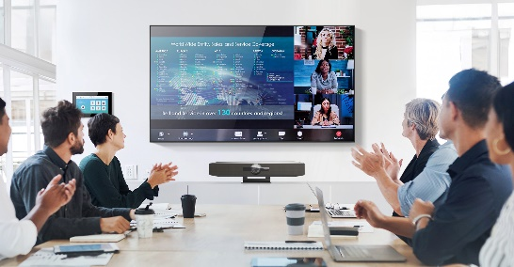MSI’s new Smart Office solution features an all-in-one AI-powered video conference bar with 4K video, auto-tracking, voice enhancement, ANC, and AGC for clear communication. Paired with a 360-degree conference camera and control panel, it enables seamless collaboration across meeting room setups and remote teams.

**Exhibition Info**

Location: Booth J0506, Hall 1, Taipei Nangang Exhibition Center

📅 Dates: May 20–23, 2025

MSI AIoT: <https://www.msi.com/to/aiot>

MSI AIoT Facebook: <https://www.facebook.com/MSIAIoT>

MSI AIoT LinkedIn: <https://www.linkedin.com/showcase/msi-aiot>

MSI Global YouTube: <https://www.youtube.com/user/MSI>

***Subscribe to MSI RSS Feeds via*** [***https://www.msi.com/rss***](https://www.msi.com/rss) ***for real-time news and more product info.***

**About MSI AIoT**

MSI integrated server in conformity to the cloud idea, satisfy the needs of customers in industrial computers, introduced robots for AI living and realized automotive electronics with human technology to provide the optimum solution of AIoT. It is also a leading brand in AI, business, and IoT market. For more product information, please go to <https://www.msi.com/to/aiot>

●All rights of the technical, pictures, text and other content published in this press release are reserved. Contents are subject to changes without prior notice.